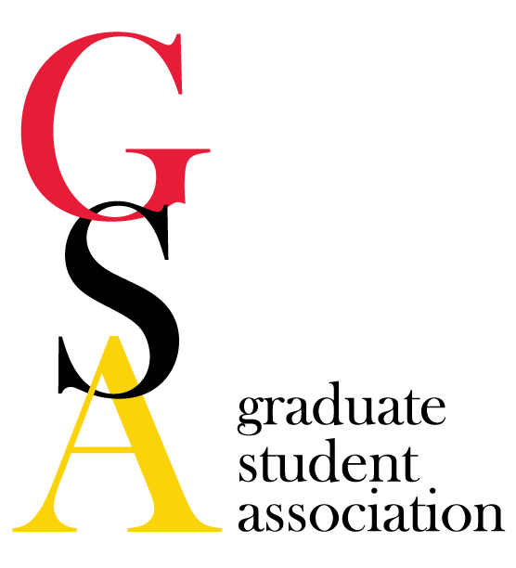
- GSA Meeting Agenda
Date: June 07, 2017

- Welcome/Call to order at 5:07 P.M.
Amanda Labuza Susannah Shissler Julia Peter Nicole Snell
Anthony Herrera Ramon Martinez Wan-wen Liao Jessica Jonkman
Lain Hostelley Morgan Bunting Courtney Chandler Yanfeng Xu
Megan Moorer Alyssa Grogan Janelle Geist Tham Le
- Review minutes of previous meeting - Motion J. Peter, D. Sharp
- Reports
  - President
    - Announcements
      - Fill out the survey really quickly! Turn in to Courtney at the end of the meeting.
      - Change your address both on SURFS and with BlueCross BlueShield if you are moving!
      - Don’t forget to register your international travel with the school here: https://www.internationalsos.com/MasterPortal/default.aspx?membnum=11BCAS519702&AspxAutoDetectCookieSupport=1, then go to My Trips on the right-hand side of the page. If you use a school travel advisor, your information should automatically be entered.
      - Religious spam email - many students got an email (in the junk folder) from Adam Mars-Heyy Dobrin that appeared to be sent from a list-serve (either group-specific or gs_all_students). These emails were not approved by moderators and did not go through the moderating process. They were reported to IT services and the sender has been blocked - if you get any more emails, please notify Courtney.
      - The Emergency Management Committee (headed by EHS) is looking for a student rep. This committee helps prepare action plans for times of emergency, which could involve natural disaster, terror plots, etc. They meet on the last Wednesday of each month from 9-10am; contact Courtney if interested; you would be required to attend USGA meetings to give a report.
      - The Grad School is turning 100! We want to form an ad-hoc committee/group to work with the school to help plan events to celebrate our 100th year of offering graduate classes. There will be a meeting this Friday (June 9th) from 2-3; email Courtney (umb.gsa.president@gmail.com) if you want to come to the meeting and/or be a part of the planning team.
    - Meet & Confer Committee
      - Dental Insurance Update - we will have an opt-in dental plan through Gallagher, which will work similar to how the Vision plan works now. It will have the same enrollment dates as the health insurance plan. It is an individual plan, so won’t need to meet certain enrollment numbers.
      - Medical Insurance Update - there are currently expected not to be any changes in our insurance between now and next year; our premiums may drop slightly. There is no more ‘metal’ testing, so this may allow for more flexibility in the future. We are pursuing a collaboration with UMBC, UMCP to create a graduate student plan. The current thought is that they would jump on our plan, which would help us lower premiums & improve our plan quality by having a larger pool.
      - Student stipends - stipends are program-specific and market-driven; to change them, start by having a conversation with the Associate Dean for Academic Affairs that presides over your program; could work with the GSA also to approach the Associate Dean
      - GRA timekeeping - it probably will be coming; we will report ‘duty days’ NOT hours; basically you just put a ‘D’ in to recognize that you worked a duty day. It is not hours driven, it will be gauged on whatever your normal duty day is (which may be different for everyone). This will be implemented to help with tax purposes/auditing (we get paid yet aren’t employees).
      - Campus safety & information dissemination - the alert system is not designed to be ‘news’, the purpose is to alert the campus of “clear and present potential danger” in real time, NOT to report crimes. It is an alert system, not a report system, and the alerts are only sent out if they are determined to represent clear and present danger to campus, not the surrounding areas. Campus police will be coming to our September meeting to talk about safety, the alert system, etc. If we want a report system, let Courtney know and she can work on setting something up for student-reported thefts, etc.
      - Graduate Student Lounge- in response to the thefts, we were given extra locks for the back cabinets. We were also given access to a lower floor storage space that currently isn’t being used to put spill-over items. Hopefully we can put some of NOVA’s stuff in there.
      - 100th year anniversary - they want us to help plan!
      - Next meeting will be in September.
  - Vice President
    - Announcements
    - Social Activities Committee - Haven't scheduled the summer social yet, but planning to do so at pickles for sometime in July
    - USGA Announcements - at the last meeting, USGA voted to increase student activity fees by one dollar a semester. USGA will now have to present to the student activities committee to determine if the fees will take effect or not in the fall
  - Treasurer
    - Account
      - Balance: $8,115.35
      - Just received USGA refund for $1,045.00 for Halal on the Lawn (amount discrepancy: $1,194.20)
    - Finance Committee
      - 3rd Quarter travel awards: 2 missed submissions were graded and both awarded $300, bringing our total for this quarter to $1,775. Although this is over the quarterly budget, we had excess money from previous quarters and still have a remainder of $375.
      - 4th quarter travel awards due July 15th: all submissions by email, Reps should not sign unless application is complete.
  - Secretary
    - Announcements - none
    - GRC

  - Grad Council rep - Megan is out of town, report read by Courtney.
    - Announcements - none
    - U of M grad council - next meeting is Sept 7
    - Professional Development Committee - no reports
  - PR
    - Announcements- Grad Gazette is done for the semester
    - Communications Committee
    - Volunteer Committee
  - Meyerhoff
  - NOVA: Still going to Springrove over the semester, looking for a new Eboard for next year
- Old Business:
  - Program reps - we will vote on how to proceed with program representation. Current doctrine is one program, one rep. We have previously discussed changing it to a scale, where programs with 1-30 students get one rep, 30-60 students get two reps, etc.
    - Vote 1: Do we want to change how programs are represented? Option 1 = KEEP the current one rep, one program doctrine. Option 2 = CHANGE the current one rep, one program doctrine. Mol Med will have about 100 students after merger and there are about 300 graduate students total. PharmSci has second largest population of around 60 students. Result: Keep how it is. Option 1: Keep current one program, one rep. All in favor of keeping the current doctrine: 12 All in favor of changing: 3 All abstain: 0
  - Foundation Account and Alternatives - vote on if we want to open an off-campus account.
    - Vote: All in favor of opening an off-campus account: 15 All opposed: 0 All abstained: 0 Result:
    - Next step will be for Courtney, Susannah, Erin G, and Jim Reynolds to meet to discuss this. We technically do not need their permission, but have a form for them to sign to ensure they were made aware of this. This will need to happen before July 1 (our T-shirt check will expire soon).
- New Business:
  - Voting on Outstanding GSA Rep
    - Current nominees: Amanda Labuza, Sarah Holmes, Susannah Shissler, Janelle Geist
    - Two winners will get $50 for being an awesome GSA rep. Winners are: Amanda Labuza and Susannah Shissler!
  - Baltimore Chapter of SACNAS between UMB and Hopkins is being established on campus. The group is a professional student group designed to promote intention and inclusion of minority groups, specifically Chicanos/HIspanics and Native Americans in science. National society - go to website http://sacnas.org to check it out. New group would most likely be one of our supported groups.
- Upcoming Events:
  - Orientation - August 23rd & 24th, Crab feast on Thurs
- Other Business/Announcements
  - Motion to cancel the July meeting J. Peter, A. Labuza

Date of next meeting: August 2, 2017
Motion to adjourn: L. Hostelley, J. Peter

